Mean:
From a list of numbers – Add the numbers and divide by the number of numbers.
e.g. Find the mean of the following:
3, 5, 8, 2, 4, 6, 4, 8, 9, 3.
Mean = $\frac{3+5+8+2+4+6+4+8+9+3}{10}=\frac{52}{10}=5.2$
From a frequency table

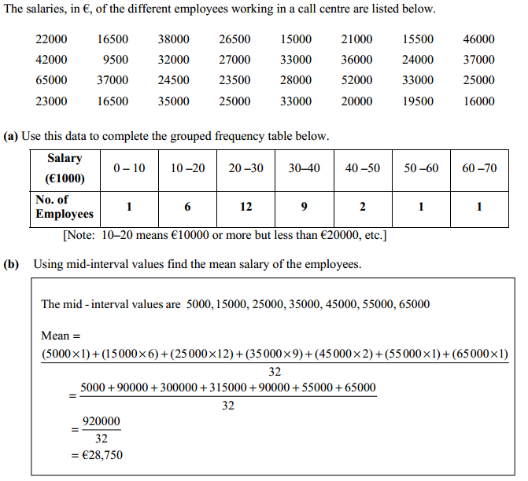

Median:
The middle number when the data is listed in increasing order.
e.g. Find the median of the following:
(i) 2. 5. 3. 7. 9 5. 4. 3. 7.
In order - 2, 3, 3, 4, 5, 5, 7, 7, 9
The median is the middle number = 5
(ii) 3, 7, 4, 5, 7, 8, 3, 6, 3, 9
In order- 3, 3, 3, 4, 5, 6, 7, 7, 8, 9
There are two middle numbers 5 and 6 so we add and divide by 2.
$\frac{5+6}{2}=5.5$
Mode:
The number that occurs most often in a list of numbers.
e.g. 4, 6, 5, 8, 7, 3, 6, 5, 3, 3, 2, 0, 7, 3
3 occurs most often so 3 is the mode.

